Week 1 Data analysis

Name of student

Name of professor

University

Course

Date

Loading the dataset onto R-studio

The preview of the dataset before loading it on Rstudio

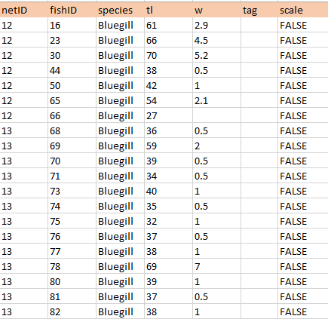

Using the view() method in R to load the data

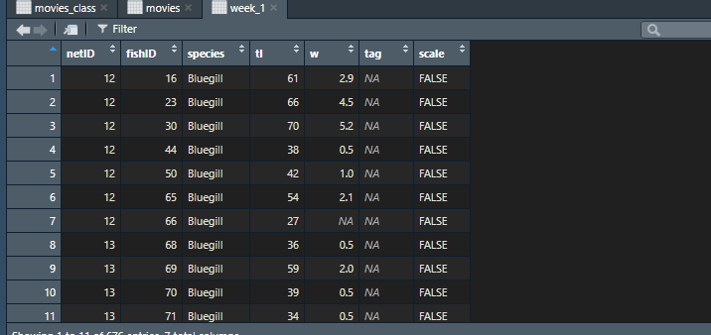

Then get a summary of the dataset as below. The summary gives the measures of central tendencies as below. This encounters the min(). Maximum, median and the quartile of each data variables

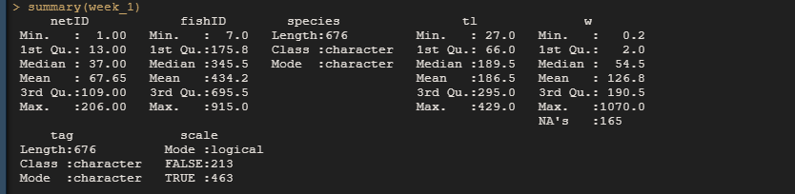

Then generating a histogram based on this dataset for the various variables

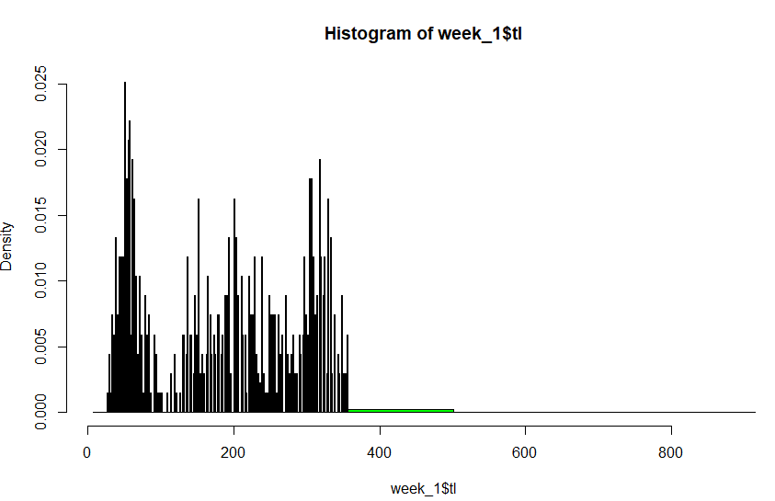

Then getting the histogram of the frequency of the tl of the data

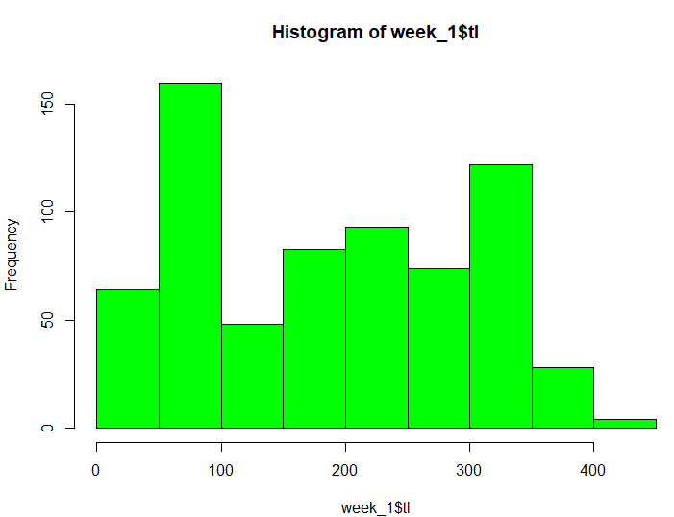

Then getting the fish w id histogram based on the frequency

